Biographical Sketch

Beatriz Adams, CPCC, ACC, MBA.
International Executive Coach for Global Coach Network
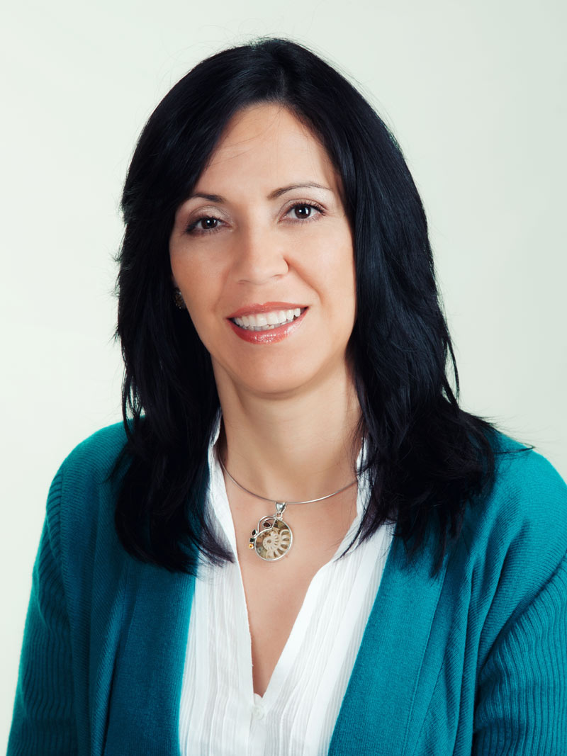

Sharjah, United Arab Emirates (U.A.E)
Languages: English and Spanish

Beatriz works with leaders and executives who want to make a difference in business and have a high leadership impact, emerging leaders who want to take a step forward and improve their leadership competencies, to inspire and motivate their teams, who work in a multicultural environment and build effective relationships and leaders and business owners who want to face new business challenges.

Beatriz believes in the capacity to transform a company, through "Coactive Coaching“ She has 5 years experience working as Human Resources Consultant and Executive Coach in Spain and around the world helping the top executive managers of international corporations to develop their skills, aligning their vision and values with the company’s and balancing their private and professional life. She has worked with entrepreneur’s start-ups and many small and medium-sized business owners to achieve their full potential.

Beatriz’s recent coaching experience includes:

- Beatriz coached the first level of Corporate Directors and Divisional Managers of a multinational telecommunications Company since 2007. The coaching program had the objective to accompany the directors and managers in a feedback evaluation 360°, identify both strengths and the areas in which management could improve, design an action plan to increase their competences and performance as well as align with their values with those of the company.
- She developed leadership training and coaching program for the new Andalucía’s General Director of a leading company in the Spanish food and agriculture sector.
- Beatriz developed a coaching program for two business partners to align their vision, mission and values with each other and with the company’s, balancing their private and professional life while elaborating their business plan to take them to higher levels.
- Beatriz is a trainer and supervisor for the CPC Program, Coaching Professional Certification Program for new coaches. This program is online and popular in Latin-American countries.
Beatriz’s client list:
Her client list includes Telefonica S.A, Movistar, Kempiski´s Hotels, UVE,S.A Group, Chamber of Commerce, CADEs, Preventor, AME Malaga (Business Women Association of Malaga, Spain), Attycas, Augere, Actividad Consultoría, Milenio, Arroyal Cantera, EON, Consulmar, Iberoamericana Corporación Universitaria.

Coaching Areas of Expertise:

Individual executive coaching for leadership development, team coaching for improving relationship, team work and promoting organizational change, debrief 360 degree feedback coaching from assessment and interviews, mentoring and coaching for leaders & coaches, empowerment coaching for women, career coaching, coaching for entrepreneurs and workshops: teaching coaching skills, developing leadership skills and improving manager’s key competences

Business/Leadership Experience:

Beatriz professional development was founded in a combination of humanities and business administration where she has been helping people to develop their skills and professional careers across diverse cultures and industries for 19 years. She had worked 10 years for companies involved in the information technology, finance and construction businesses in Colombia, where she specialized in human resources; 1 year as Manager of Business Affairs, Embassy of Uruguay, Riyadh, Saudi Arabia; 3 years as Managing Owner of a Services Franchise Company, Marbella, Spain and the last 5 years as Human Resource Consultant and Certified Executive Coach for top level executives of international corporations with several HR Consultants Companies and her own coaching business. Now she is facing a new professional challenge, expand her business to U.A.E

Certifications:

Beatriz has trained and certified with: CTI – The Coaches Training Institute where she is Certified as a Professional Coactive Coach (CPCC); ICF - International Coaching Federation where She is Certified as an Associate Coach (ACC); The Leadership Circle for managing leadership and cultural assessments, TLCP and TLCS; ORSC – Organization & Relationship Systems Coaching Fundamentals.

Education:

Beatriz holds several academic degrees; a B.S. in Psychology from the University of the Andes, a degree in Human Resources Management from Javeriana University, and has studied business administration ultimately receiving an M.B.A. from the University Externado of Colombia.

Affiliations:

The International Coach Federation, ICF.AME Malaga (Malaga´s Women Business Association)

Coaching Philosophy:

Coaching is a powerful conversation and experiential process to co-create a client´s new reality and develop new competencies. The Coactive coaching in which Beatriz is certified is based on learning and a continuous action process where she has access to several resources and methods that promote insight and commitment to action. It creates a significant jump in awareness regarding why executives do what they do, what is stopping them, what their deepest desire and purpose in life and projects them forward, step by step in their action plan. By discovering underlying thinking patterns that drive their current behavior, executives have access to new choices and possibilities. Her coaching method allows her clients to discover awareness and choice in their professional and personal life in order to live a fulfilled life, aligned with their own life purpose and values.

